Project design phase - II Technology architecture

|  |  |
| --- | --- |
| **Date** | 26-10-2022 |
| **Team ID** | PNT2022TMID39239 |
| **Title** | Estimate the crop yield using data analytics |

# Technology architecture:

The technology architecture describes the infrastructure required to support applications, operations, and reporting requirements.

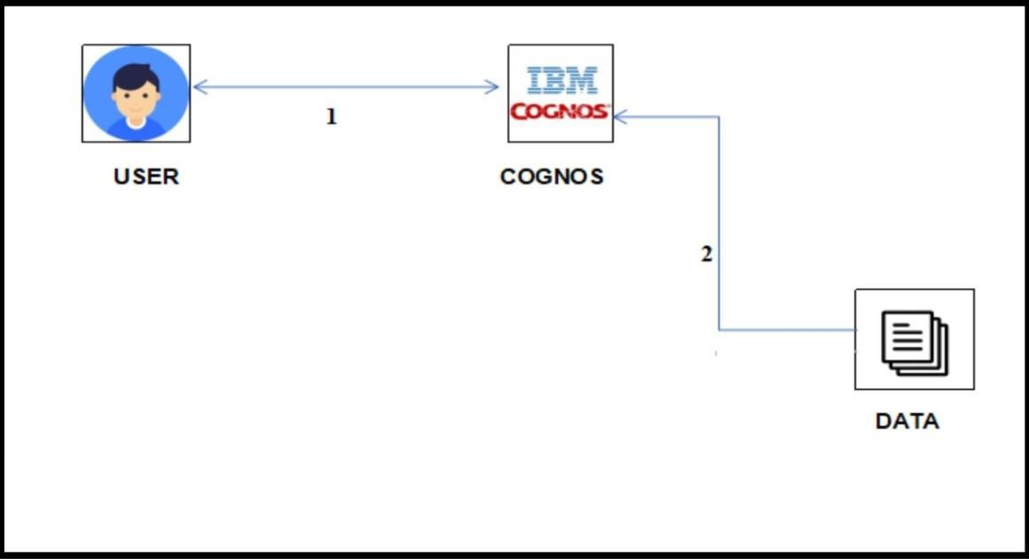

# Is the system robust?

Yes, the software that is being developed for data analysis is robust

# Is it highly modifiable?

Yes, the system is user friendly and ready for developers to make changes and enhance it

# Is it scalable?

Yes, the system can be scaled up when there is a need and is flexible.

# Is it buildable?

Yes, it is feasible to build at a low budget.